

American International University-Bangladesh (AIUB)  
**Department of Computer Science  
Faculty of Science &Technology (FST)  
Spring 22 23**

**TrackMate: Railway Arrival Prediction System**

Software Requirement Engineering

Sec: **A**

Project submitted

By

*SOURAV MANDAL (19-39568-1)*

*IN JAM IFTA KHAR NUR (20-43040-1)*

*SHOPNAMOY SAHA PRONOY (19-41199-2)*

*DIPUNKOR SARKER (18-37976-2)*

**Checked By Industry Personnel**

Name:

Designation:

Company:

Sign:

Date:

1. **PROBLEM DOMAIN**
   1. **Background to the Problem**

It has occurred many times when you have been waiting for someone to arrive at the railway station and you have no accurate information about train timetable and other things. Waiting for someone at a railway station may be an unpleasant experience, especially if you don't know the precise train time or other vital facts. Whether you're waiting for a loved one or a business acquaintance, the unknown of when they'll come may be stressful.

One of the most prevalent causes for not knowing exact train times is a breakdown in communication between the traveler and the person waiting at the station. Travelers frequently fail to notify their companions of any delays or changes in their trip arrangements.

And this can be very time consuming and irritating for every people. Its can be decrease our productivity.

* 1. **Solution to the Problem**

Therefore, we present to you this project on Arrival Time Prediction and Railway Tracking. Utilizing this system client 's can get the data about train timing, and is it on time or not, and other data. The system will keep track of the train's departure time from one station and transmit this information to the system at the other station, which will then display the train's departure time. If the system detects a train delay caused by a signal, it will display the train's timing in the next station and automatically update it.

This system has an admin module that enters train information and its timing. These details are sent to a server on the internet and retrieved by the system at other stations. Another system displays train information to viewers on the platform. The second system will obtain all of the data for all trains, but it will only display the data that pertains to a specific station and will automatically select that data.

For instance, The Kamlapur Station system will display train information if an administrator at Chittagong Station enters information about Kamlapur Station. The Comilla Station system will not be affected. This system works like this: when a train leaves a station late, the administrator enters details about the departure and its time. This information is sent to an internet server in real time, retrieved from another system via the internet server, and the details are displayed on the screen. For viewers to view the information, this second system is installed in various stations. The administration will include information such as the train's departure from the station, anticipated arrival at the destination, and any schedule delays. Subscribing client applications receive real-time train schedule events from this project.

1. **SOLUTION DESCRIPTION**
   1. **System Features**

**Admin Features**

* Can Register in the system.
* Can Log in and Log out.
* Can add train details.
* Can add departure time of all train.
* Can add departed time and departed train information.
* Can update the information like delays , departure time.
* Can show the estimated time from departure to arriving of the train.

**User Features**

* Can Register in the system.
* Can Log in and Log out.
* Can see all train details.
* Can track the train details.
* Can Complain to the train authorities.
* Can shear the train details with others after departed from any station.
* Can see the total travelling time from the system.
* Can see the every location of the train.

* 1. **UML Diagrams**

**Use Case Diagram :**

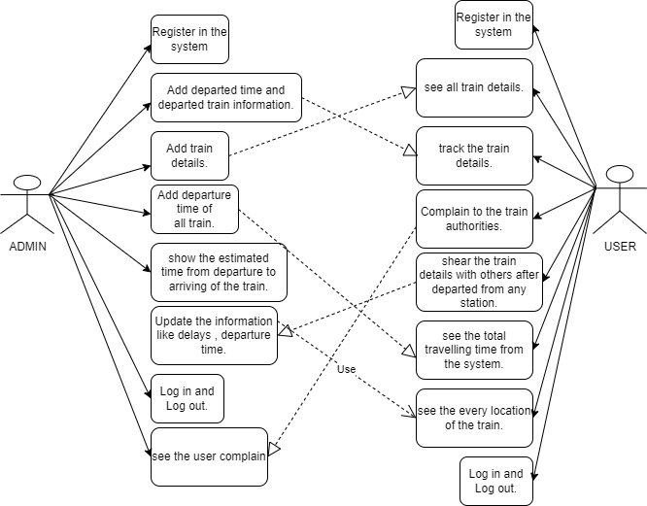

*Fig 1: -Use Case Diagram*

The use case diagram shows the system's interactions with two primary actors: Admin and User. The Admin has access to use cases for managing train information, while the User has use cases for viewing and tracking trains, filing complaints, and sharing information.

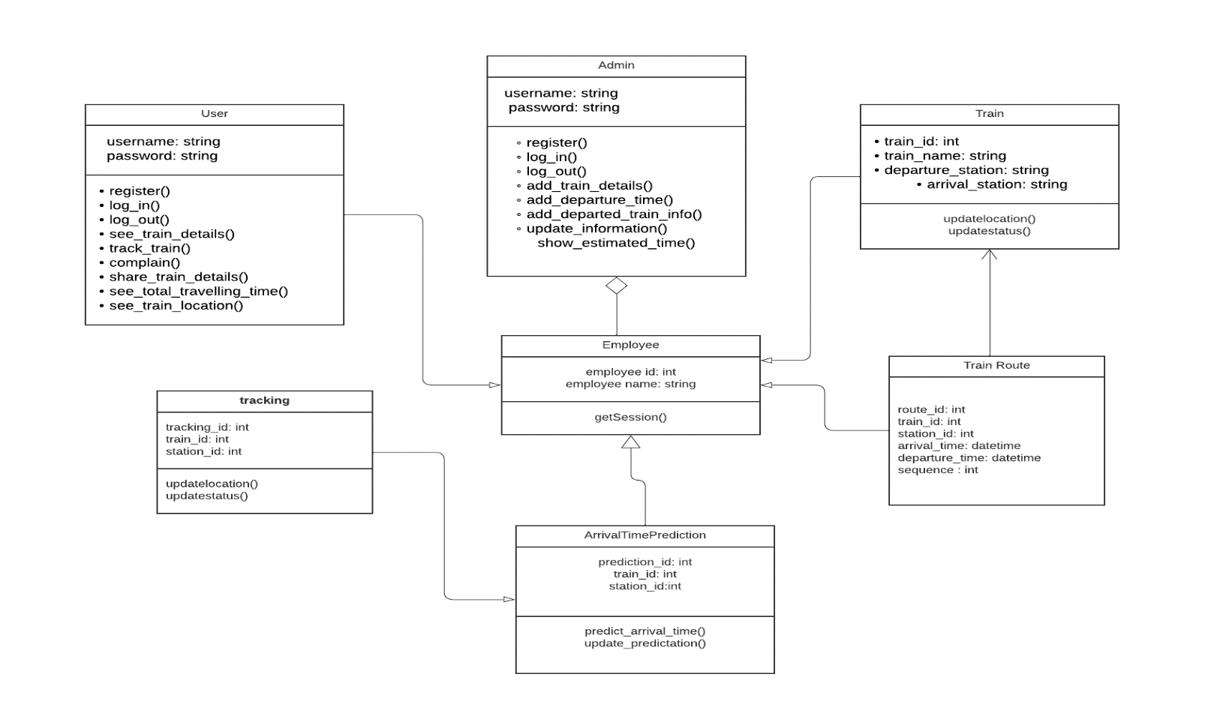**Class Diagram :**

Fig 2 :- Class Diagram

This class diagram represents three classes: User, Admin, and Train, along with their associated attributes and methods.

The User and Admin classes have similar attributes and methods, including username, password, register, log_in, log_out, and several other methods related to train information, such as see_train_details and track_train.

The Train class has attributes for identifying the train, such as train_id, train_name, and the departure and arrival stations. There are no methods associated with the Train class.

Overall, this class diagram depicts a system with two types of users: Admin and User, and a Train class with attributes related to train identification and station information*.*

**Activity Diagram :**

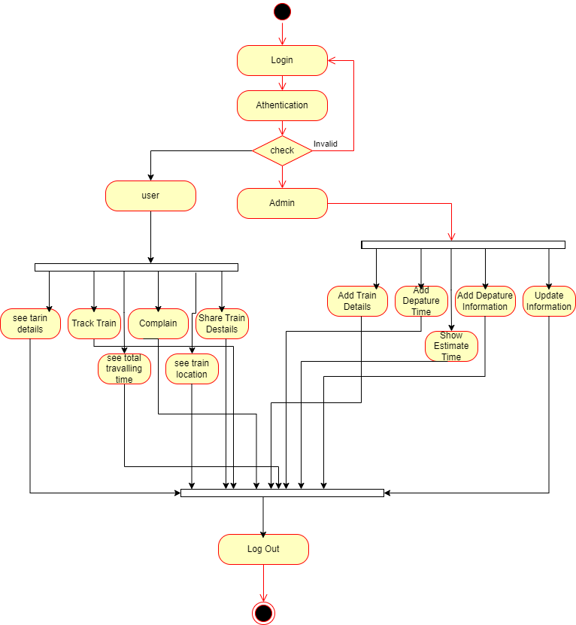

Fig 3 :- Activity Diagram

This activity diagram depicts the various actions that an admin and a user can perform on a train tracking system. The admin can register, log in, add train details, add departure time, add departed train information, update information, and show estimated time. The user can register, log in, see train details, track train, complain, share train details, see total travelling time, and see train location. Each action is represented by a rectangular box, and the flow of actions is depicted using arrows. The diagram provides an overview of the system's functionality and how the different actions are connected.

1. **Social Impact**

A project to track trains and predict arrival times can have a number of positive social effects.

To begin, it has the potential to significantly boost the overall effectiveness of railway transportation. Rail operators can better manage their fleets and routes with the help of precise tracking and prediction systems, minimizing delays, enhancing scheduling, and making passengers' journeys more reliable and comfortable.

Second, it may result in increased passenger and staff safety. Arrival time predictions can help passengers plan their journeys and avoid accidents caused by rushing or overcrowding, and real-time tracking can assist operators in quickly identifying and responding to potential safety hazards.

Thirdly, it may benefit the environment by encouraging people to take trains instead of planes or cars, thereby lowering carbon emissions and contributing to the fight against climate change.

Last but not least, the project has the potential to benefit the economy by making rail travel more appealing, generating employment opportunities in the rail industry, and supporting local economies through an increase in business and tourism travel.

A valuable project with a positive social impact, the implementation of a TrackMate system has the potential to significantly enhance the efficiency, safety, environmental impact, and economic viability of railway transportation.

1. **Development Plan with Project Schedule**

**Project Estimation**

We used COCOMO model for project estimation. The product we are developing is a semi-detached project. That’s why we are using 25000 SLOC.

So,

Coefficient=3.0;

P=1.12;

T=0.35;

SLOC=25000.

Effort = PM = Coefficient*(SLOC/1000) ^ P

**=** 3.0*(25000/1000) ^1.12

= 110 person months

Development Time = DM = 2.50*(PM) ^ T

= 2.50*(110) ^ 0.35

= 13 weeks

Required number of people = ST = PM/DM

= 110/13

= 9 Persons (rounded up)

Productivity = SLOC/Effort

= 25000/110

= 227 SLOC / person-week

Based on this estimation, we will need a team of 9 members to develop the software within a time frame of 13 weeks. We will divide the project tasks as follows:

|  |  |
| --- | --- |
| Weeks | Tasks |
| Week 1 | Requirement Gathering |
| Week 2 | Project Planning |
| Week 3 | Team selection and Scheduling |
| Week 4 | Analysis and Risk Management |
| Week 5 | Specification Analysis and Time Estimation |
| Week 6 | Design and Development [1] |
| Week 7 | Design and Development [2] |
| Week 8 | Design and Development [3] |
| Week 9 | Front-end Development [1 |
| Week 10 | Front-end Development [2] |
| Week 11 | Back-end Development [1] |
| Week 12 | Back-end Development [2] |
| Week 13 | Quality Testing and Maintenance |

We will require the following key team members with their projected daily work hours and hourly rates:

|  |  |  |  |
| --- | --- | --- | --- |
| Team Member | Total Number | Hour/Day | Hourly Rate |
| Business Analyst | 1 | 6 | 800 |
| Senior Developer | 2 | 6 | 750 |
| UX Designer | 1 | 4 | 700 |
| Front-end Developer | 2 | 3 | 700 |
| Back-end Developer | 1 | 3 | 650 |
| Quality Tester | 1 | 5 | 600 |

Based on the above hourly rates and daily work hours:

The estimated monthly development cost will be:

Total Hourly Rate * Total Daily Work Hours * Number of Working Days in a Month

= (800 * 6*1) + (750 * 6 * 2) + (700 * 4*1) + (700 * 3 * 2) + (650 * 3 * 1) + (600 * 5 * 1) *22

=566,500 BDT.

Therefore, the estimated total project development cost will be:

Total Monthly Cost * Development Time in Months

= 566,500 * 3

= 1,699,500 BDT.

So, the estimated development cost for the railway tracking and time prediction software is 1,699,500 BDT.

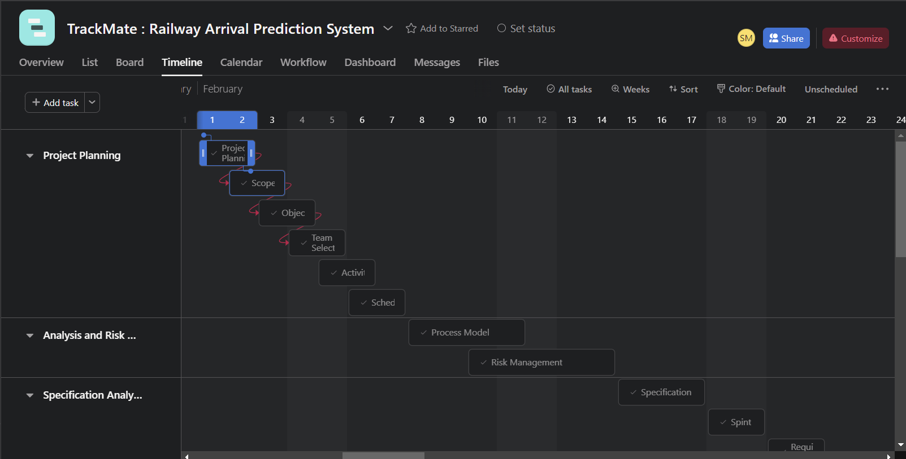**Project Schedule**

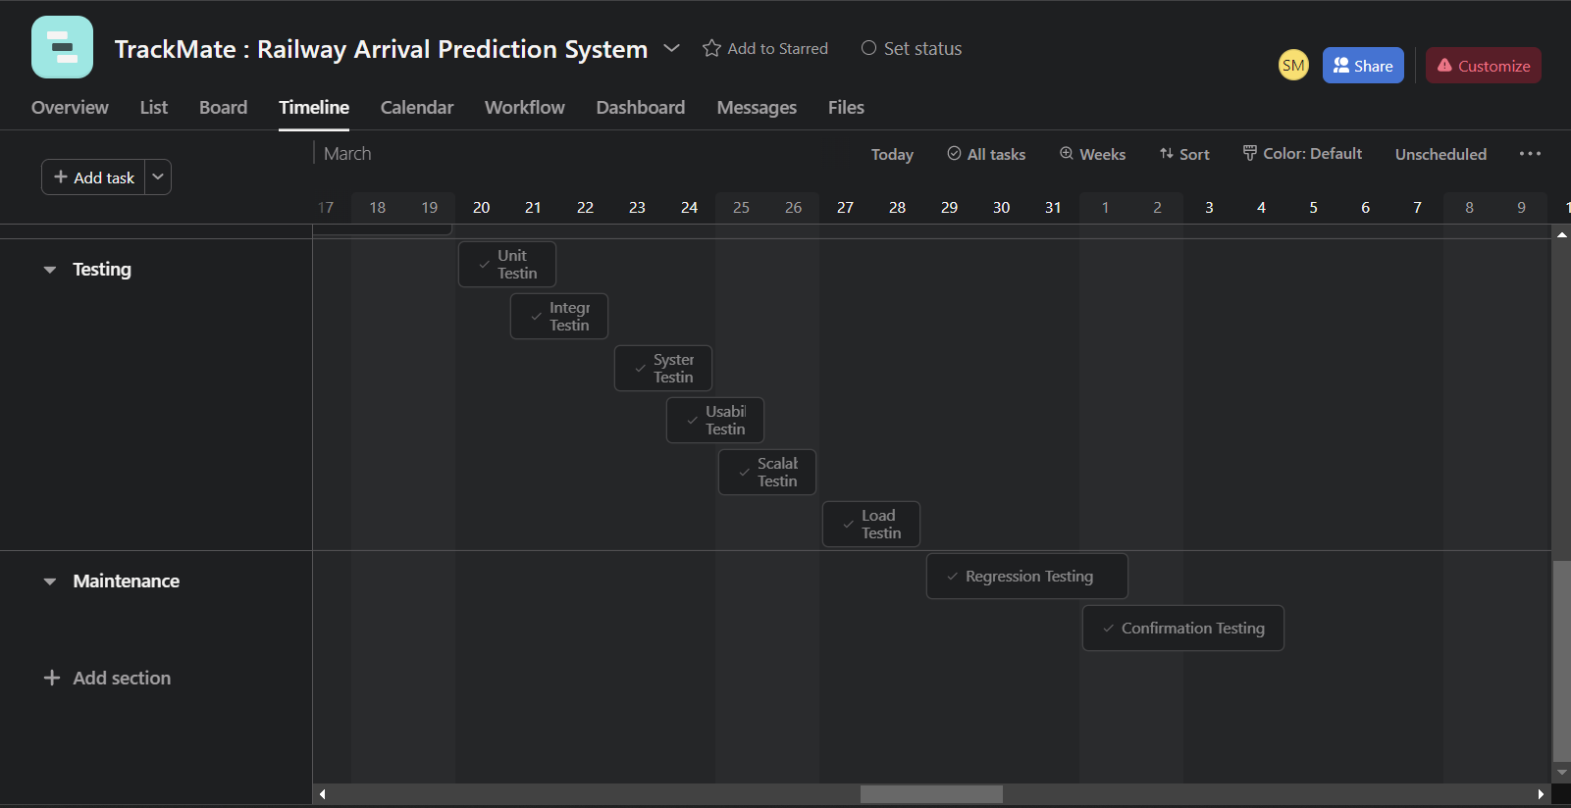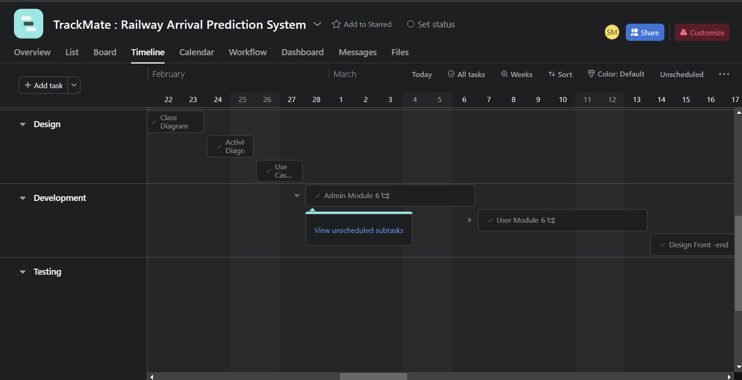

**Development Plan**

We will begin by gathering the project requirements of our software from our customers and listen to various stakeholders. Then we will analyze the requirements and prioritize them and eventually make a baseline requirement of our software which must be fulfilled in development process. Our designing team will then be starting designing the UML diagrams and make a proper prototype of what should be implemented during development. Documenting the requirements and finally make an SRS document will be our primary goal before reaching the development phase. Afterwards developers of our team will to commence the development part. When the development phase completes, quality assurance team will be testing the beta version of our software and may advice developers for further improvement or if any mistakes are made then that will be mended.

**Elicitation**

Conduct interviews and surveys with railway operators, passengers, and other stakeholders to gather their requirements and expectations for the system. Identify the key features and functionalities that the system should have, such as real-time train tracking, estimated arrival times, route planning, and passenger notifications.

**Documentation**

Create a Software Requirements Specification (SRS) document that outlines the system's features, functionalities, and technical specifications.

Develop Use Case diagrams, Sequence diagrams, and other UML diagrams to visualize the system's architecture and functionality.

**Design**

Develop a prototype of the system's user interface and workflow. Design the database schema, APIs, and other technical components required for the system. Review and iterate on the design based on feedback from stakeholders.

**Development/Coding**

Build the system's backend using a suitable programming language and framework. Develop the frontend of the system using a modern web framework and user interface components. Integrate third-party APIs and services as needed. Implement real-time train tracking, arrival time prediction algorithms, and route planning functionality. Conduct regular code reviews and testing to ensure the code quality and functionality of the system.

**Testing**

Perform functional testing to verify that the system's features and functionalities are working as expected. Conduct non-functional testing to test the system's scalability, reliability, and performance under different load conditions. Perform user acceptance testing to get feedback from stakeholders and identify any remaining issues or bugs.

**Deployment**

Deploy the system to a staging environment for final testing and quality assurance. Once the system has been thoroughly tested and approved, deploy it to a production environment for public use. Monitor the system's performance and user feedback to identify any issues or opportunities for improvement.

**Maintenance and Updates**

Provide ongoing maintenance and support for the system, including bug fixes, updates, and security patches. Incorporate user feedback and feature requests into future updates and iterations of the system.

Continuously monitor the system's performance and user feedback to ensure it remains up-to-date and meets the needs of its users.

1. **Marketing Plan**

* **Executive Summary**

This marketing strategy is for a software that predicts arrival times and tracks trains. The product is intended to give ongoing following and appearance time expectations for rail line travelers. This marketing strategy aims to spread the word about the software, raise awareness of the brand, and boost sales.

* **Market Analysis**

The software market for TrackMate is expanding rapidly. There is a growing demand for software that can provide real-time information about train schedules, delays, and cancellations in response to the rising number of railway passengers. There are a lot of players in the market, making it very competitive. Nonetheless, the market is as yet open to new players who can offer imaginative arrangements.

* **Target Market**

Train passengers who are looking for real-time information about train schedules, delays, and cancellations are the target market for this software. Railway operators who want to boost customer satisfaction and enhance their services can also benefit from the software. Passengers on both domestic and international flights can make use of the software.

* **Marketing Strategies**

1. **Marketing on social media**

Increase brand awareness and engage with potential customers by creating and maintaining social media accounts on Facebook, Twitter, and LinkedIn. On these platforms, run targeted ads to reach a larger audience.

1. **Influencer Marketing**

Partner with influencers in the travel and transportation industry to promote the software to their followers. Offer them a free trial of the software and incentivize them to promote it to their audience.

1. **Content Marketing**

Create high-quality blog posts, videos, and infographics about the software and its features. Use SEO techniques to optimize the content for search engines and drive traffic to the website.

1. **Email Marketing**

Construct an email rundown of expected clients and send them ordinary pamphlets with refreshes about the product, advancements, and limits.

1. **Referral Marketing**

Give current customers incentives to recommend the software to their friends and family. This could come in the form of special deals, free trials, or other perks.

1. **Partnership Marketing**

Promote the software to customers through collaboration with travel agencies and railway operators. Give them a commission for each new client they bring in who uses the software.

1. **Cost and Profit Analysis**

|  |  |  |  |
| --- | --- | --- | --- |
| Team Member | Total Number | Hour/Day | Hourly Rate |
| Business Analyst | 1 | 6 | 800 |
| Senior Developer | 2 | 6 | 750 |
| UX Designer | 1 | 4 | 700 |
| Front-end Developer | 2 | 3 | 700 |
| Back-end Developer | 1 | 3 | 650 |
| Quality Tester | 1 | 5 | 600 |

Estimated Monthly Development Cost: 566,500 BDT

Estimated Total Project Development Cost: 1,699,500 BDT

**Annual Marketing Cost :**

Social media marketing: 10,000

Influencer marketing: 5,000

Content marketing: 5,000

Email marketing: 2,000

Referral marketing: 3,000

Partnership marketing: 5,000

Total budget: 30,000 BDT

**Annual Office Rent and other Cost:**

Rent: 400000/-

Utility Bills: 60000/-

Maintenance: 100000/-

So, in total the cost is 2,28,9500/- in one year including software development.

**Total Earnings :**

This is the first railway tracking software in Bangladesh . From a survey we find that in 1996 to 2016 the train passenger number increased 5.62 % and the number is 10,040 Million passenger-km . And now a days its increased more . So, from that passenger we will target 100000 passenger in one year and the charge for every user is 50 BDT for getting the service.

So, total earning from our system in one year: 100000 * 50 = 50,00000 BDT

**Profit Analysis :**

After one year of releasing our software the total cost will be 2,28,9500 BDT

And total earning will be around 50,00000 BDT

So total profit after 1 year: (50,00000 - 2,28,9500) = 2,710,500 BDT

1. **Reference**

* <https://nevonprojects.com/railway-tracking-and-arrival-time-prediction>
* <https://chat.openai.com/chat>
* <https://www.geeksforgeeks.org/software-engineering-requirements-engineering-process>
* <https://knoema.com/atlas/Bangladesh/Number-of-passengers-carried-by-railways>